Identify the Level of Measurement for the following (#1-4)
- The volume of a chemical solution needed in a laboratory experiment.
- Nominal b) Ordinal c) Interval d) Ratio
- The GPA of a student graduating from a Pre-Health Sciences Program.
a) Nominal b) Ordinal c) Interval d) Ratio
- The temperature set in a resident’s room in a nursing home.
a) Nominal b) Ordinal c) Interval d) Ratio
- Type of animal brough into a veterinarian’s office.
a) Nominal b) Ordinal c) Interval d) Ratio
Identify which sampling method would be most appropriate for the following studies (#5-8).
- Determining the average emergency room wait time at Toronto General Hospital.
- Cluster Sampling
- Convenience Sampling
- Stratified Random Sampling
- Systematic Sampling

- Health Canada wants to conduct a study on pay equity of physicians across Canada knowing that each provincial government has their own regulations.
- Cluster Sampling
- Convenience Sampling
- Stratified Random Sampling
- Systematic Sampling

- Determining overall patient satisfaction with the level of care in a local hospital.
- Cluster Sampling
- Convenience Sampling
- Stratified Random Sampling
- Systematic Sampling

- A pharmaceutical company did a clinical drug trial with 500 participants and wants to select 250 of them for the treatment.
a) Cluster Sampling
b) Convenience Sampling
c) Stratified Random Sampling
d) Systematic Sampling

Identify the following variables as either discrete (D) or continuous (C). (#9-12)

- Number of patients assigned to each nurse D C
- Treatment cost not covered by OHIP. D C
- Position of a patient on a organ-transplant waiting list. D C
- Duration (i.e., length of time) of an operation D C

Identify the following variables as either ‘quantitative’ or ‘qualitative’ (Q#13-16)

- Letter grade on a final exam quantitative qualitative
- Height of a patient quantitative qualitative
- Number of vertebrae injured in a fall quantitative qualitative
- Ontario Health Card Number quantitative qualitative

Q#17-22. The following data give the six most frequent tupes of cancer-related deaths in a hospital in the past three months. The are lung (L), breast (B), colorectal (C), pancreas (P), liver (LV), and stomach (S).

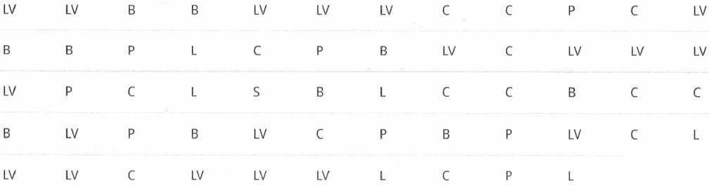

Organize the data in a frequency table.

Qu#/ Type of Cancer | Frequency (f)
17. Lung (L)
18. Breast (B)
19. Colorectal (C)
20. Pancreas (P)
21. Liver (LV)
22. Stomach (S)

(Q#23-28) Victoria kept a record of the average number of hours she spent on different activities during the weekdays. Complete the table for percent and angle (to be used in the construction of a pie chart).

Activity | # of Hours | Percent (%) / Angle (º)
School | 7.0 | (#23) __________ / ___________
Meals | 1.0 | (#24) __________ / ___________
Homework | 2.0 | (#25) __________ / ___________
Travel | 2.5 | (#26) __________ / ___________
Sleep | 8.0 | (#27) __________ / ___________
Other | 3.5 | (#28) __________ / ___________
Total | 24 | 100% / 360º

(Q#29-36) Observe the following frequency table, representing the number of deaths for the six most frequent types of cancer in a hospital over the past three months:

Qu#/ Type of Cancer | Frequency (f) | Relative Frequency (RF) (%)
29. Lung (L) | 12
30. Breast (B) | 9
31. Colorectal (C) | 10
32. Pancreas (P) | 11
33. Liver (LV) | 5
34. Stomach (S) | 8

35. What percent of deaths were due to pancreas cancer? _________%

36. Using the frequency column in the table above, what is the ratio of breast cancer-related to colorectal cancer-related deaths? _______ : ________

(Q#37-39) Use the multi-bar chart below to answer the following questions:

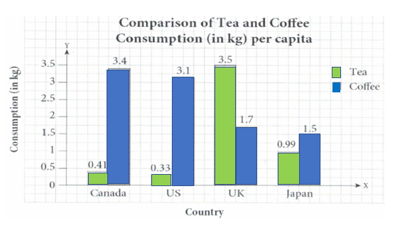
37. Which country has the biggest difference in their tea and coffee consumption?
a) | Canada
b) | US
c) | UK
d) | Japan

38. What is the difference between the amounts of tea and coffee consumed in the UK per capita? _____kg

39. What is the ratio of tea to coffee consumption per capita in the US? ______

(Q#40-45) The frequency distribution below was constructed from the data collected from students at a college. Using the frequency distribution below to construct the Relative Frequency Distribution.

Qu# | Height (cm) | Frequency (f) | Relative Frequency (Rf)
40. | 155 to under 160 | 8
41. | 160 to under 185 | 2
42. | 165 to under 170 | 5
43. | 170 to under 175 | 1
44. | 175 to under 180 | 8
45. | 180 to under 185 | 7

(Q#46-49) The following pie chart shows the percentage of blood donors of each blood type who participated in the previous blood drive at the college:

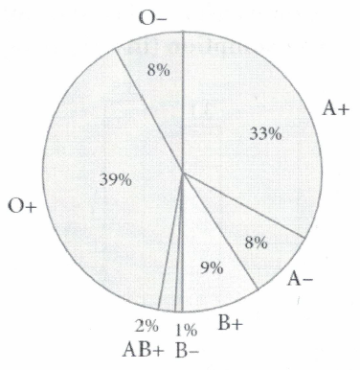
46. Which blood type has the least amount of donors?
a) | A-
b) | AB+
c) | B+
d) | B-
47. What is the ratio of donors with type O+ blood to those with type O- blood? ________ : _________
48. What percent of donors have an A-type (i.e., A+ or A-) of blood? ___________
49. If there were a total of 150 donors, how many donors had blood type AB+? ___________

(Q#50-53) The following graph shows the average weights and cholesterol levels of a patient per month over one calendar year. Based on the multi-line graph, answer the following questions.
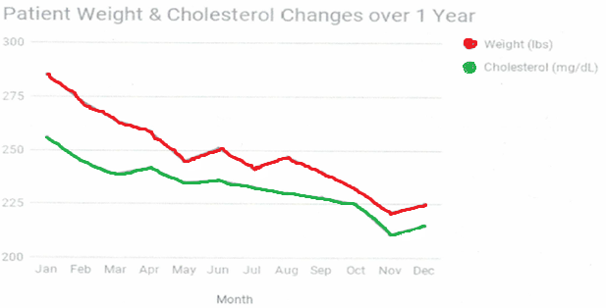
50. What is the trend of the patient’s weight over the year? Increasing decreasing
51. What is the trend of the patient’s cholesterol level over the year? Increasing decreasing
52. What is the percent change in the patient’s weight from the beginning of the year to the end? Assume that the patient’s weight at the beginning of the year was 285 lbs. __________%
53. What is the percent change in the patent’s cholesterol level from the beginning of the year to the end? Assume that the patient’s cholesterol level at the beginning of the year was 256 mg/dL, and the cholesterol level at the end of the year is 215 mg/dL _________%

(Q#54-57) The price-per-share data for a sample of 26 pharmaceutical companies is arranged in a stem-and-leaf plot below.
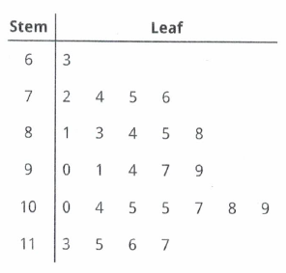
What are the
54. highest price $_______
55. lowest price $_______

56. How many companies have a price-per-share of $100 or more? ________

57. Do any companies have the same price-per-share? Yes No

The Next (Last) Two Pages are the only pages to be uploaded/handed-in.
58. Construct a stem-and-leaf plot to display the following students’ final grades data in an array. Please Hand In/ Upload this page including the Answer Sheet.
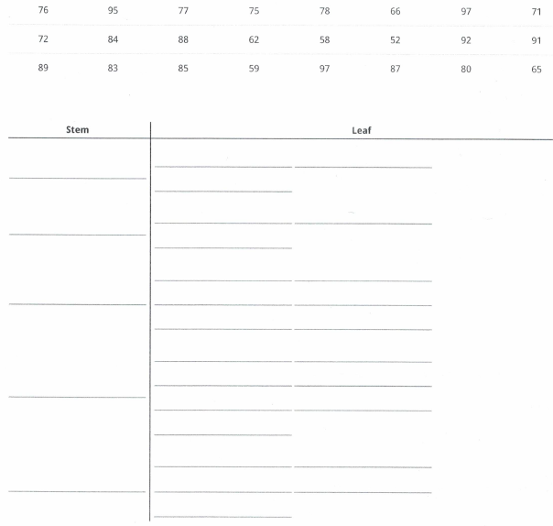

59. Use the following frequency distribution taken from data obtained for the number of minutes spent in an E.R. room before seeing a doctor. Place answers here, not on Answer Sheet.

Time (min) | Frequency (f) | Relative Frequency (%) | Cumulative Frequency | Relative Cumulative Frequency (%)
12-36 | 4
37-61 | 2
62-86 | 6
87-111 | 6
112-136 | 3

Ques # | Answers | Ques # | Answer
1 |  | 30
2 |  | 31
3 |  | 32
4 |  | 33
5 |  | 34
6 |  | 35
7 |  | 36
8 |  | 37
9 |  | 38
10 |  | 39
11 |  | 40
12 |  | 41
13 |  | 42
14 |  | 43
15 |  | 44
16 |  | 45
17 |  | 46
18 |  | 47
19 |  | 48
20 |  | 49
21 |  | 50
22 |  | 51
23 |  | 52
24 |  | 53
25 |  | 54
26 |  | 55
27 |  | 56
28 |  | 57
29

